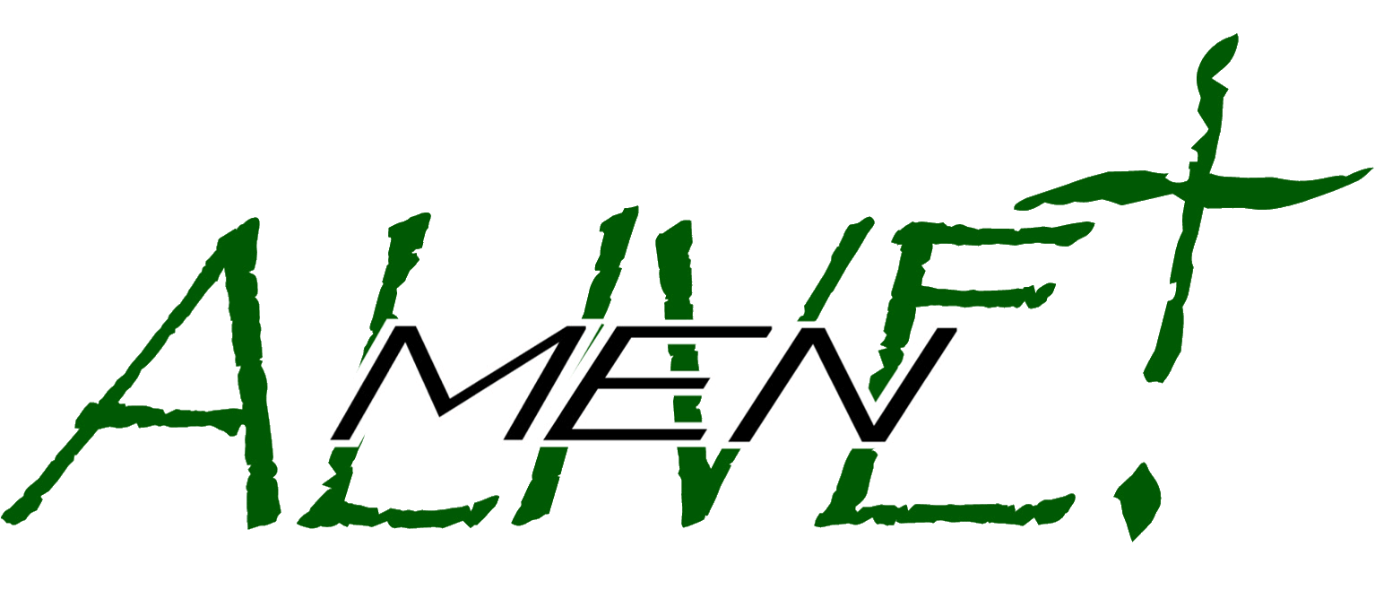
2023 Rally
SPONSORSHIP
APPLICATION
Saturday, February 18, 2023
at the DOUBLE TREE HOTEL, BAY CITY, MI
“WALKING WITH GOD”
Men Alive! is a group of Christian men who encourage one another to live their lives in service to our Savior and his people with an annual rally that is a gathering not intended to dwell on problems but to find renewed strength and joy. Men Alive! depends on the support of our sponsors to provide a quality rally experience at a lowest possible cost so that all may attend. If you have sponsored our rally in the past, THANK YOU! If this is your first time, we are grateful for your support.

- DIAMOND Sponsorship is a donation of $2,000 or more. At this level, your sponsorship will be acknowledged on the inside of the front cover and on the back cover of our full-color rally folder. It may include your business logo. Your organization will also be verbally acknowledged at the rally.
This level includes one adult registration ($65 value).

- PLATINUM Sponsorship is a donation of $1,000 or more. At this level, your sponsorship will be acknowledged on the back cover of our full-color rally folder. It may include your business logo. Your organization will also be verbally acknowledged at the rally.
This level includes one adult registration ($65 value).

- GOLD Sponsorship is a donation of $500 or more. At this level, your sponsorship will be acknowledged inside our full-color rally folder. It may include your business logo.
This level includes one adult registration ($65 value).

- SILVER Sponsorship is a donation of $300. At this level, your sponsorship will be acknowledged inside our full-color rally folder. It may include your business logo.

- BRONZE Sponsorship is a donation of $100. At this level, your sponsorship will be acknowledged inside our full-color rally folder. No logo is printed at this level.

All sponsorship checks must be received by January 20, 2023. Donations are tax deductible. Logos may be emailed in .jpg format to mike.nitz@bethanysaginaw.com. All received logos will be acknowledged by email reply.

Please make checks payable to: MEN ALIVE /BALM
Mail to: Pastor Mike Nitz, 5051 McCarty Rd, Saginaw, MI 48603

Include the way you wish your sponsorship to be printed here or on the back:

Signature: Title/Position: _______

